Name KEY

#1. (3 pts) What is a “namespace” in C++ ? (Answer by giving the language definition.)
(give 2 points for an “OK” answer – one that clearly has the essential idea I am looking for; give 3 points to the best answer; otherwise give no points.)
They create a named frame for encapsulating related types, data, functions, and classes. Names declared in a name space are accessed using the scope resolution operator (::), unless a using declaration is given.
OR
A namespace is an encapsulation unit used to group declarations and definitions with a common scope. Namespaces can encapsulate the following kinds of declarations:
  - Constant and variable declarations
  - Struct, union, and class declarations
  - Function prototypes
  - Function definitions
  - Nested namespaces.

#2. (3 pts) What is the primary purpose of a “namespace” in C++ ? (Answer by giving a software engineering definition.) (give 2 points for an “OK” answer – one that clearly has the essential idea I am looking for; give 3 points to the best answer; otherwise give no points.)
Namespaces are used in the development of large software systems to avoid potential conflicts among names defined by different individuals or groups working independently on parts of the same software system. Namespaces must themselves be uniquely named, but once their names have been agreed upon by different development groups, the groups are free to use whatever names they feel appropriate within their respective namespaces. Using the syntax, namespace::identifier, a reference to the entity denoted by identifier can be made unique, even if it is defined in multiple namespaces.
#3. (3 pts) There are three kinds of namespaces. What are they? (1 point each)
(a) Global
(b) Transation Unit (File)
(c) Named

#4. (6 pts) For each type of namespace identified in question #3, give an example by defining a variable “x” to be of type int within that namespace. Describe the context in which your example must be written. Refer to (a), (b) and (c) to identify which namespace you are giving. (Give up to two points for each correct example.)
Global Namespace: any definition that is enclosed by a source file, but not enclosed by any other type of frame.
int x; // declared at the file level and not part or inside the definition or declaration of any other entity.
TU Namespace: an anonymous namespace defined at the file level and not enclosed in any other frame. It restricts the scope of its internal entities to be limited to the file in which the namespace is defined.
namespace { //anonymous
int x;
}
Named namespace: a namespace frame defined with a unique identifier at the file level and not enclosed in any other frame.
namespace alpha {
int x;
}

#5. (15 pts) Study the C++ source code given in the attachment to this exam. Fill in the blanks associated with each statement in the main() function as prescribed in the comments field. Copy your answers below. (all or nothing on each part)
(a) (2 pts) ::u
(b) (2 pts) ::x
(c) (4 pts) alpha::cube(alpha::x) or cube(alpha::x)
(d) (3 pts) beta::Point
(e) (2 pts) 12.0
(f) (2 pts) 32.0

#6. (20 pts) In the space provided below, write the implementation file (“alpha.cpp”) for the namespace alpha. Use the comments in the header file, “alpha.h”, as a guide to your
implementation. (2 pt for .cpp)(3 pts for #include and using directive)
(3 pts for namespace{})(1 pt for data definitions) (2 pts each for each function or method)
//file "alpha.cpp" ======================================================================
#include “alpha.h”
3 pts
using namespace alpha; //optional
namespace alpha {

x = 9.0; //initialized to 9.0
y = 8.0; //initialized to 8.0

float cube( float z ){
returns z*z*z;
}//cube

Point::Point() { x = y = 0.0;} //initialize data members to 0.0
Point::Point( float X, float Y) { x = X; y = Y;}// initialize data members from parameters
float Point::getX() { return x; } // X inspector
float Point::getY(); { return y; } // y inspector
}
//end "alpha.cpp" =====================================================================
#7. (15 pts) The following question relates to the different design styles: Functional⁻, Functional⁺, OO⁻and OO⁺.
(a) (4 pts) Regarding the Functional⁻ style, which of the following attributes were used in the design and which were not. Fill in the blank with used or not used.
not used data encapsulation
used information hiding
used reuse
used control encapsulation
(b) (6 pts) Regarding the Functional⁺ style, identify the two qualities that improved most significantly over the Functional⁻ style. In each case describe how the improvement was realized in the design.
data encapsulation was used by creating separate files to encapsulate the Vector type and the functions that manipulate that type. (3 pts)
reuse was greatly enhanced by adding functions to give two external views of vectors (Cartesian and polar) plus IO functions for inputting and outputting vector objects. (3 pts)
(c) (3 pts) Regarding the OO⁻ style, identify the most significant improvement, other than change in the implementation language, over the Functional⁺ style. Why was the change to C++ necessary to support this improvement?
information hiding : this was accomplished by encapsulating the Vector type in a class and declaring the data members private. The language change was necessary to enforce the concept of access (visibility) attributes for data members.
(d) (2 pts) What was the most significant improvement in the OO⁺ style compared to the OO⁻ style?
reusability: encapsulating reusable classes in namespaces and adding ProblemMgr, Problem, and Line classes as well as exception classes for handling errors.
#8. (35 pts) Consider the Florida Toll Road System. To be more specific, you are asked to develop a Use Case Model for the Toll Gate subsystem described below.

The Toll Gate provides two payment methods to Florida motorists. One lane is dedicated to E-pass (or Sun-pass) customers. Payment using this option is electronic. Vehicles are equipped with a transponder that identifies the vehicle (and therefore the owner’s E-pass account) as it passes through the gate. A traffic light flashes green if the transponder’s signal was recognized, it flashes red if not. In either case, a camera captures the vehicle’s license plate image as the vehicle leaves the gate. The license plate can be used to bill the car owner if the transponder is not recognized. Electronic transactions are recorded locally at the Toll Gate in computer files and are then uploaded weekly to the central billing facility in Tallahassee.

The second payment method is by cash transaction. One or more lanes may be dedicated to this payment method. Motorists must pay by cash and can optionally accept a receipt of their toll transaction. Change is given if the amount paid exceeds the amount of the toll. A toll gate arm prevents a motorist from proceeding through the gate until proper payment has been received. The toll attendant raises the toll arm when the transaction has been successfully completed. It is then lowered after a sensor detects that the vehicle has cleared the gate arm. Cash receipts are picked up daily by an armored security service.
(a) (6 pts, 2pts each actor) Identify (at most five) Actors in the Toll Gate subsystem.
Motorist (Toll Customer)
Central Billing (Tallahassee)
Armored Security Service
(b) (5 pts, 1pts each use case, at least 5) Listed below are three use cases.
List at least five others.
(a) Pay Toll Fee
(b) Pay by Cash
(c) Pay Electronically
(d) Identify Vehicle (by transponder)
(e) Signal Vehicle Recognition
(f) Photograph License Plate
(g) CreateTransaction
(h) Upload Weekly Transaction File
(i) Make Change
(j) Produce Receipt
(k) Raise/Lower Toll Arm
(l) Transfer Cash to Bank
(c) (10 pts; 2 pts each correct answer) Identify the relationship between each of the following pairs of ordered use cases.
Choose your answer from among: association, specialization, generalization,uses,
includes, extends.
(a) to (b) (a) Generalizes (b) (not extends)
(c) to (a) (c) Specializes (a) (not extends)
(b) to (i,j,l) association (not include)
(b) to (k) includes
(c) to ( d,e,f,g ) includes
(c) to (h) association
(g) to (h) association (optional – matter of interpretation)
all other pairs association (use your judgement)
(d) (14 pts) Draw a Use Case Diagram for the Toll Gate subsystem showing all actors identified in part (a) and five use cases from (b) (including use cases (a),(b) and (c)) such that each actor is related to at least one of the use cases. Then draw all the relationships among the actors and use cases.
system boundary & title (2 pts)
actor – use case connected by association (6 pts total)(deduct 1 point for missing associations)(deduct 2 pts for missing actor)
Relationships between use cases (6 pts) must have correct connector for the relationship. Deduct 2 points if a relationship is given when there should be a relationship.

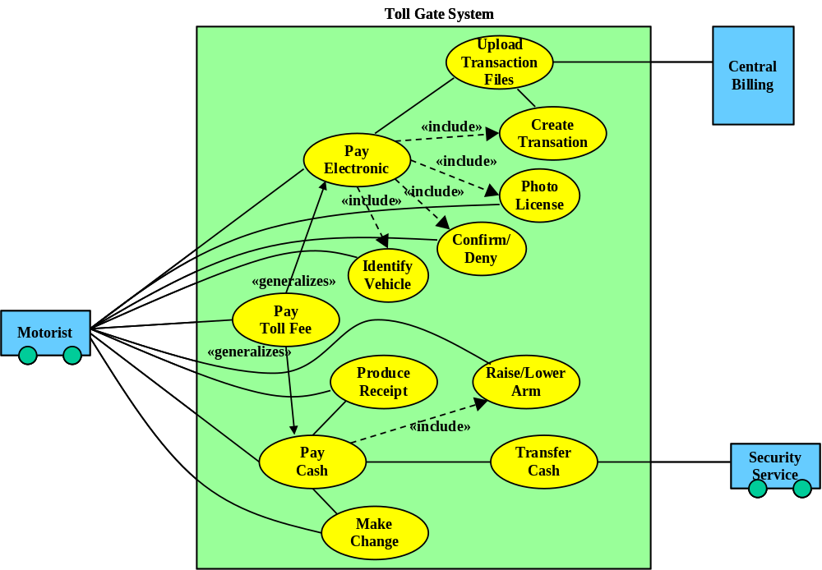
Attachment for Questions #5 and #6

//QUESTIONS: 5 and 6

//file "alpha.h" ======================================================================
namespace alpha {

float x; //initialized to 9.0
float y; //initialized to 8.0

float cube( float z ); // returns z*z*z

class Point {

float x,y;

public:
Point(); //initialize data members to 0.0
Point( float X,
float Y); // initialize data members from parameters
float getX(); // X inspector
float getY(); // y inspector
};//Point

}
//end "alpha.h" =====================================================================

//file "beta.h" ======================================================================
namespace beta {

const int x; //initialized to 5
const int y; //initialized to 6

int cube( int z ); // returns z*z*z

class Point {

int x,y;

public:
Point();
Point( int X, int Y);
int getX(); // X inspector
int getY(); // y inspector
};//Point

}
//end "beta.h" ======================================================================

//file "app.cpp" =======================================================================
#include "alpha.h"
using namespace alpha;

#include "beta.h"
using namespace beta;

namespace {
int x = 4;
float y = 4.0;
}

int u = 2, v = 3;
float r = 2.0, s = 3.0;

int main() {
int u, v, x;
float r, y;

u = ::u ; //(a) value of u in the global namespace

x = ::x; //(b) value of x in the Transaction Unit namespace

r = alpha::cube(alpha::x) ; //(c) cube of x defined in namespace alpha by
//calling the function "cube" in namespace alpha
or

r = cube(alpha::x) ; // the parameter type uniquely determines which
// definition of “cube” will be called – both are visible
// because of the using directives.

beta::Point p(u, x) ; //(d) give the correct type for variable "p".

y = s * p.getY(); 12.0 //(e) give the value of y

using alpha::y;

r = y*::y; 32.0 //(f) give the value of r

return 0;
}//main

//end "app.cpp" =======================================================================

